**“DOMESTIC VIOLENCE”**

**Members:**

**Salarzon, Zakiya Marie**

**Pesares, Calvin James**

**Sabater, Kairalyn**

**Gonzales, John Lester**

**Barcos, Ryken Heart**

**Christian Living Education**

**Grade 9D**

**Mr. Rainheart Pinuela**

**Project Proposal:**

**Members Insights:**

**Zakiya Marie Salarzon:**

Hello, my name is Zakiya Marie Salarzon from class 9D and my insights about our chosen topic which is domestic violence is; Addressing this kind of issue will help families or individuals live freely without any taunt from any individuals who are close to them.

**Calvin James Pesares:**

Hello my name is Calvin James Pesares coming from the class of 9D and my comprehension about our topic on Domestic abuse is that it is one of the most dreadful action that come in my mind. Because abusing, controlling and emotionally abusing is always supposedly considered as an inhumane thing to do which on whoever try to act on it should be kept an eye on.

**Kairalyn Sabater:**

I am Kairalyn Sabater from class 9D. Both women and men can be victims. People of all ages, backgrounds and incomes can be affected. And it can happen in any sexual relationship — gay, straight, or otherwise.

**John Lester Gonzales:**

Hello, my name is Jonn Lester Gonzales, and I'm from class 9D. My ideas on our selected topic, domestic violence, are that it impacts one's thoughts, feelings, and behaviors, as well as has a big impact on one's mental stability. Survivors of domestic violence frequently experience increased anxiety, post-traumatic stress disorder, and depression symptoms.

**Ryken Heart Barcos:**

Hello my name is Ryken Heart Barcos from 9D class and my insights about Domestic violence is that it’s a very destructive behavior in an intimate relationship in which one person attempts to dominate and control another in a dating, marital, or cohabiting relationship, causing physical, psychological, or sexual harm to those in that relationship.

**3 Objectives:**

1.) To make people understand the true definition of domestic violence.

2.) To increase people’s knowledge and victims’ understanding about their rights.

3.) To increase people’s awareness about this deep-rooted issue and for the victims to get free from their abusers.

**Introduction:**

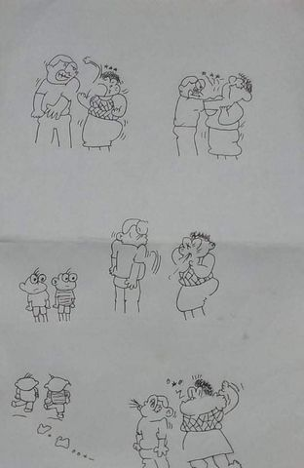

Domestic violence or abuse is more than just physical abuse, it is also about the behavior that aims to gain power and control over a partner or an intimate family member. Everyone deserves to escape and to get free from that kind of behavior and relationship. Emotional, sexual, and physical abuse, stalking, and threats of abuse are all examples of domestic violence. It can occur in heterosexual as well as same-sex partnerships. There are a lot of causes of domestic violence, it includes lack of understanding, abusive behavior, frustration, fighting over money, drug and alcohol, and exposure to violent medias. Through these causes, it could create a very harmful home for families. Church does help those families who are in need and had experience domestic violence. It is stated the Church can serve as safe place for families and will help a person recover spiritually and emotionally. The Church affirmed their stance about domestic violence and their support for those victims of domestic violence.

**Rationale:**

This advocacy aims to help individuals who are experiencing getting abused within their households. Domestic violence is a deep-rooted issue because we never know what is truly happening inside someone's home, and we never know if they're only wearing their fake faces whenever they're out. This issue affects our family members, friends, and many other members of our community. Domestic violence has a serious consequence for those who experienced, it can ruin their mental and physical health. It may be difficult to gather evidences of abuse however, never lose hope, put a courage and put the abusers where they belong. Within this advocacy, this could help people who are suffering. Let's help them get up and get away from their abusers. Let's value the humanity within us.

**Solution:**

1.) Call out abusers

2.) Don't ignore someone who is experiencing domestic violence

3.) Collect evidences

4.) Lend an ear to someone who's opening up about their painful experiences.

5.) Be courageous

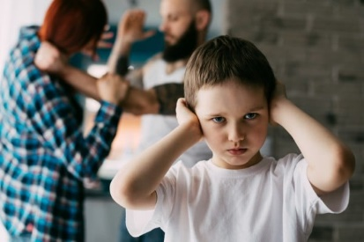

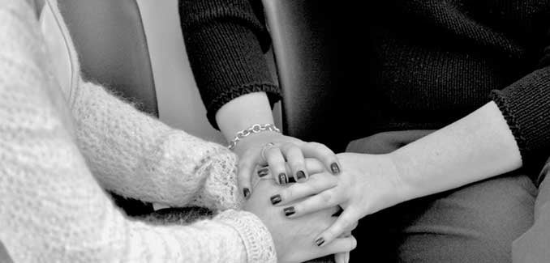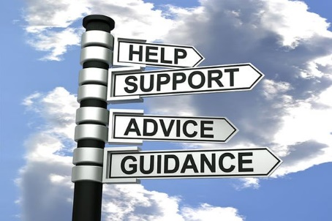

**Prayer:**

Father God, ever caring, ever strong, stand by us in our times of need. Hear the cries of our brothers and sisters. Soothe their broken hearts. Heal their minds that is full of chaotic thoughts and traumas. Grant them the justice and peace they deserve. Enlight people with the truths. May your Holy Spirit bring them wisdom, humility and grace. And when they feel worthless and hopeless, may you remind them how a piece of beautiful art they are and is worthy to receive love and happiness. Calm their hearts and thoughts and guide them as they continue to survive in life. Thank you Dear God. Amen.